cldv6212 - part 1
Group 7: Thamsanqa Nkosi Ncube - ST10482062 Kandyce Smit - ST10467645 Kristen Keve - ST10472683

Lecturer: Farshida Wania
Module Code: CLDV6212

Table of Contents
YouTube and GitHub link: 2
YouTube Link: 2
GitHub Link: 2
TEAM MEMBER CONTRIBUTIONS 3
Menu Management (Kandyce) 4
Staff Documents (Kristen) 4
Docker (Thami) 4
local.settings.json: 5
Docker Containers Running (Thami): 5
Docker Hub Public Images (Thami): 6
Postman Collection (Thami): 6
GitHub Commit History / Contributors: 8
GitHub Pull Requests Merged: 9
References 10

YouTube and GitHub link:

YouTube Link:

GitHub Link:

TEAM MEMBER CONTRIBUTIONS

Name | Student Number | Role | What they built
Kandyce Smit | ST10467645 | Menu CRUD & Documentation Lead | MenuItem model, all 5 Menu HTTP functions (Create, GetAll, GetByCategory, Update, Delete), README
Kristen Keve | ST10472683 | Staff Documents (Blob Storage) | UploadStaffDocument, ListStaffDocuments, DownloadStaffDocument functions
Thamsanqa Ncube | ST10482062 | Docker & Docker Hub | Dockerfile, Docker Hub image publishing, Azurite container setup

FEATURE DESCRIPTIONS

Menu Management (Kandyce)
The Menu Management feature uses Microsoft Azure’s Table Storage to digitalise CoffeeNChill’s chalkboard menu for their coffee shop. With five HTTP triggered Azure Functions that handle full CRUD operations of the menu items (creating, reading, updating, and deleting): create a new menu item (Microsoft Learn, 2025b), read all available menu items (Microsoft Learn, 2026c), read only specific menu items by category (Microsoft Learn, 2022), and updating and deleting menu items (Microsoft Learn, 2026c). This storage system stores each menu item with its category as the Partition Key and a unique SKU as the Row Key. In addition, it includes name, description, price and status fields for each menu item. Validation logic has been implemented in each function to validate the input data when creating a new record (validation for bad request 400 when missing data exists). Also, there have been existence checks included for update and delete operations to prevent unexpected errors from occurring (return a 404 Not Found instead of an unhandled exception).

Staff Documents (Kristen)
The Staff Documents feature allows the canteen staff to upload, view and download important documents using Azure Blob Storage. When a file is uploaded the system checks that it's either a PDF, PNG or JPEG before storing it, so other file types can't be uploaded by mistake (Microsoft Learn, 2026f). All the uploaded documents are stored in a container called "staff-docs" and users can list every file that's currently stored, along with its name, size and the date it was last modified (Microsoft Learn, 2026e). Files are also downloaded using streaming, which sends the file to the user instead of loading the whole thing into memory first making it more efficient for larger files (Microsoft Learn, 2026d). Each function also includes error handling and logging so any problems such as a missing file or a storage connection issue are caught and logged instead of crashing the app.

Docker (Thami)
My contribution to Part 1 of the POE was the Docker setup. I wrote multi-stage Docker file for the Azure Functions project, the beginning stage used the full .NET 9 SDK image to compile and publish the code, the second stage then copied only the compiled output into the lightweight Azure Functions runtime image, keeping the final image small and clean (Microsoft Learn, 2026a) (Microsoft Learn, 2026b). I also built and tagged both images with version tag v1.0 and published them directly to the Docker hub under the account st10482062: “coffeenchill-functions” for the Azure Functions application and “coffeenchill-azurite” as a re-tagged instance of the official azurite image (Docker, 2026a), (Docker, 2026b), (Docker, 2026c), (Docker, 2026d). Azurite also runs in its own standalone Docker container with the “—skipApiVersionCheck” flag bound to ports 10000, 10001, and 10002, and both contains communicate with each other over a shared docker network called “coffeenchil-net” (Microsoft Learn, 2025a), (Microsoft Learn, 2026b).

EVIDENCE SCREENSHOTS

local.settings.json:
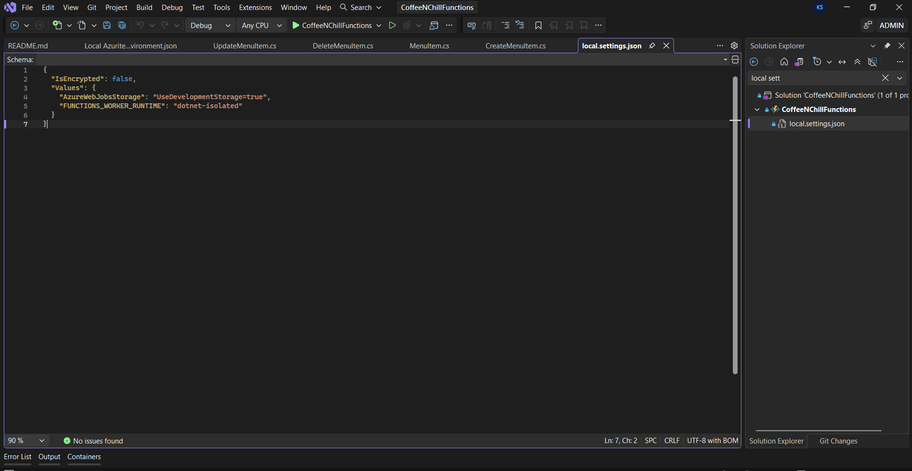

Docker Containers Running (Thami):
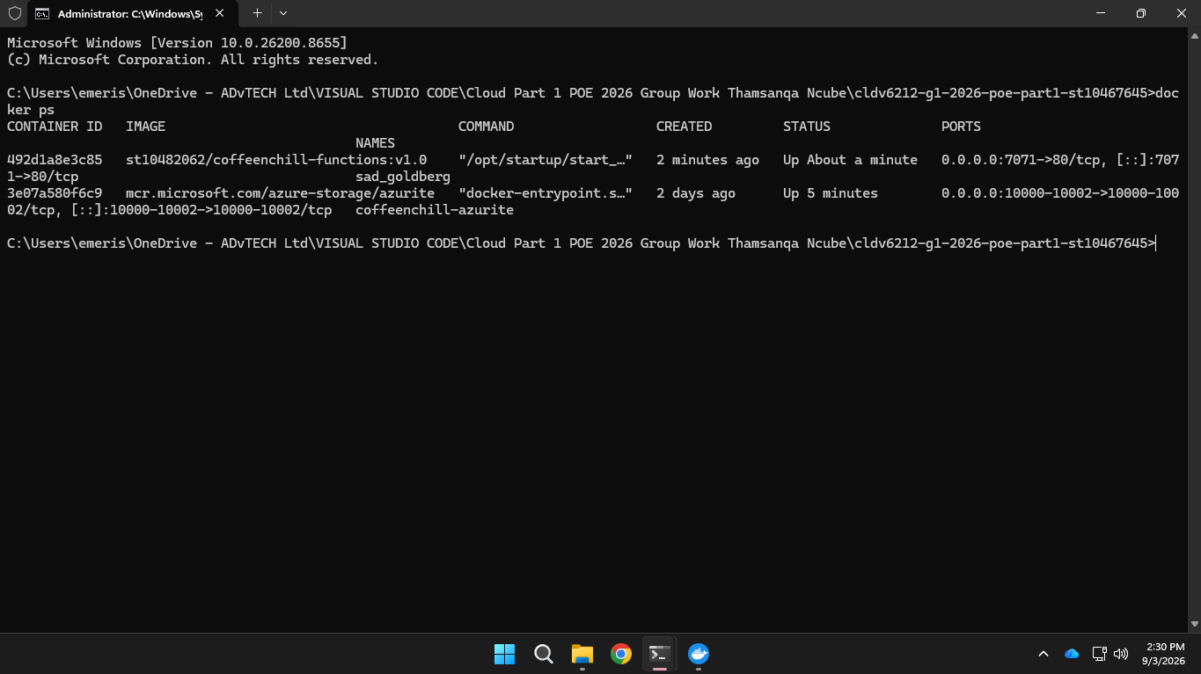

Docker Hub Public Images (Thami):
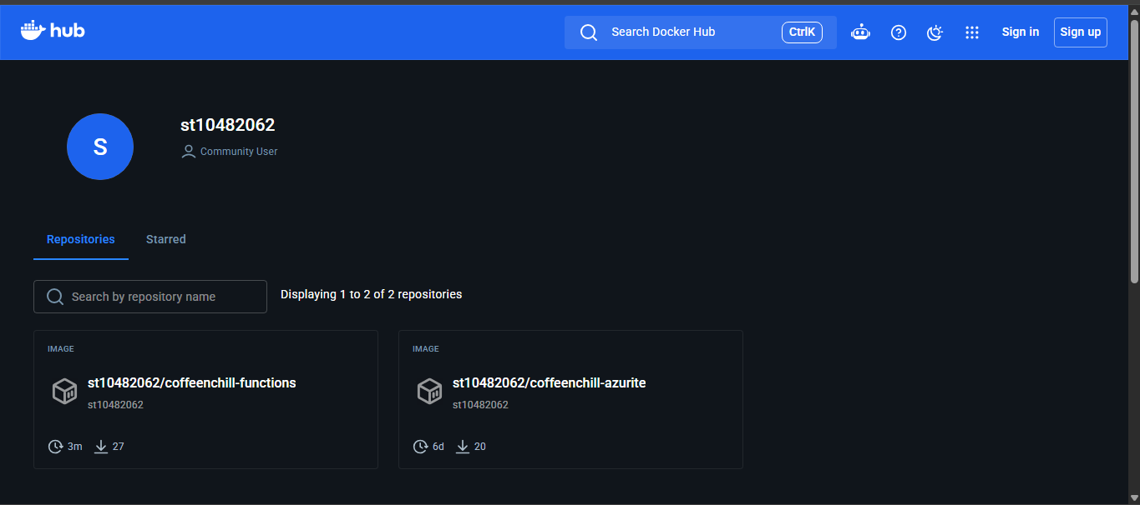

Postman Collection (Thami):
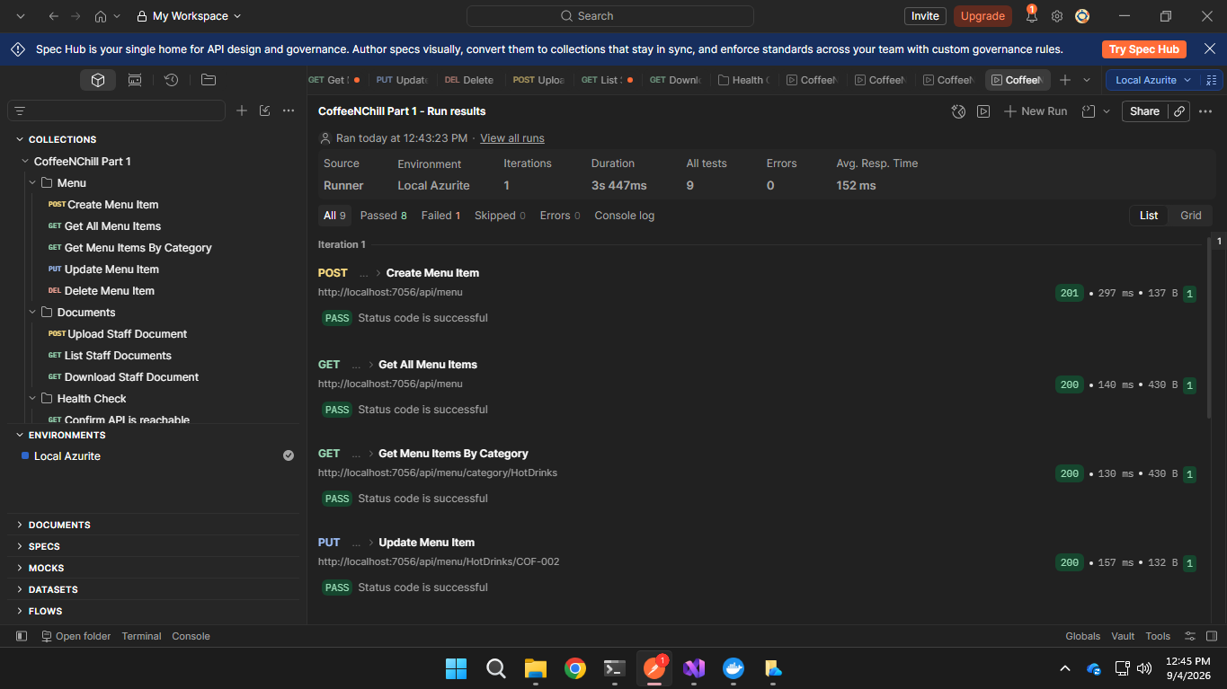
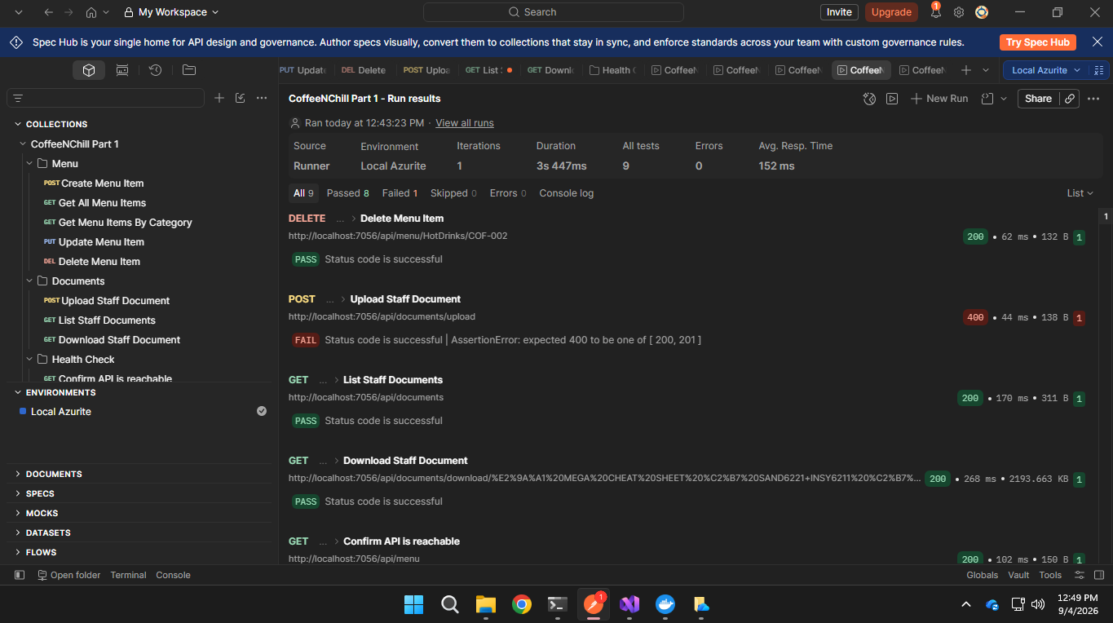
Upload staff documents fails when it is run together with everything, but works when it is tested individually.
See below:
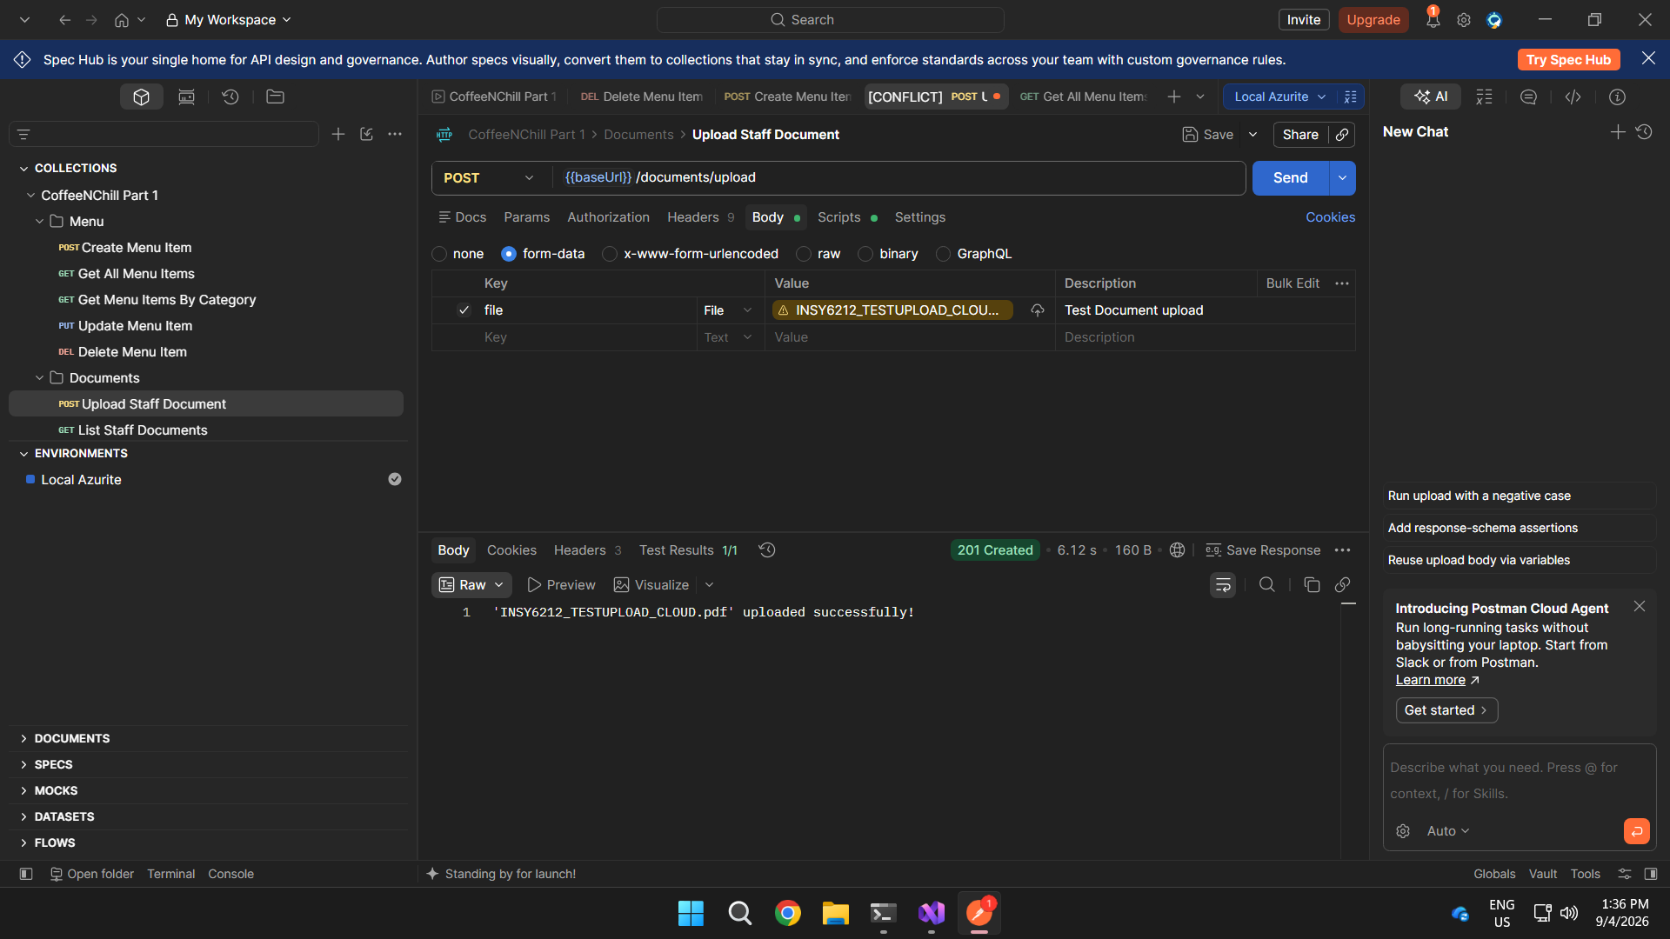

GitHub Commit History / Contributors:
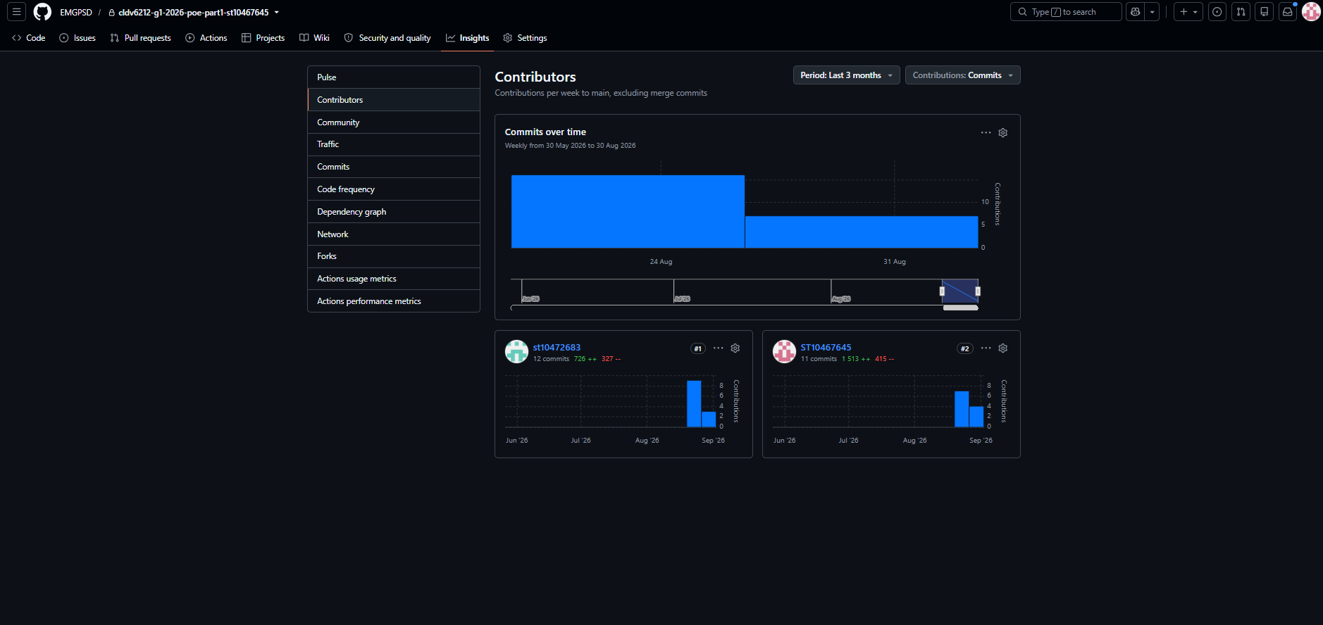
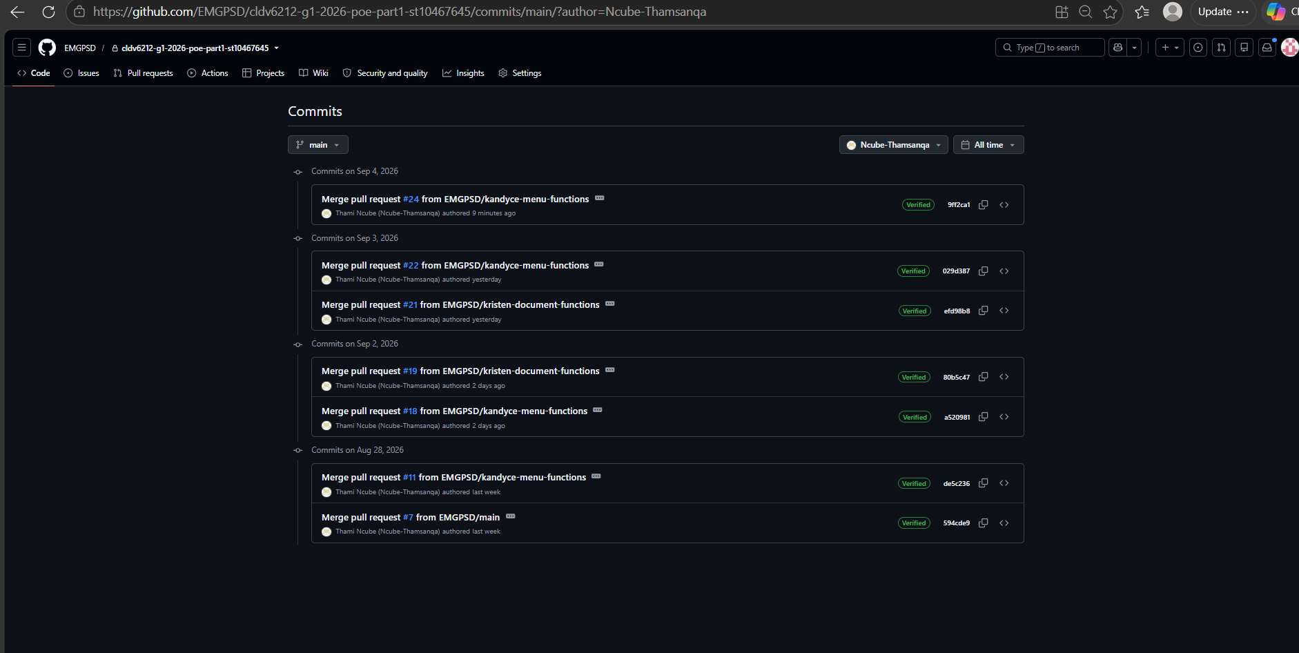

GitHub Pull Requests Merged:
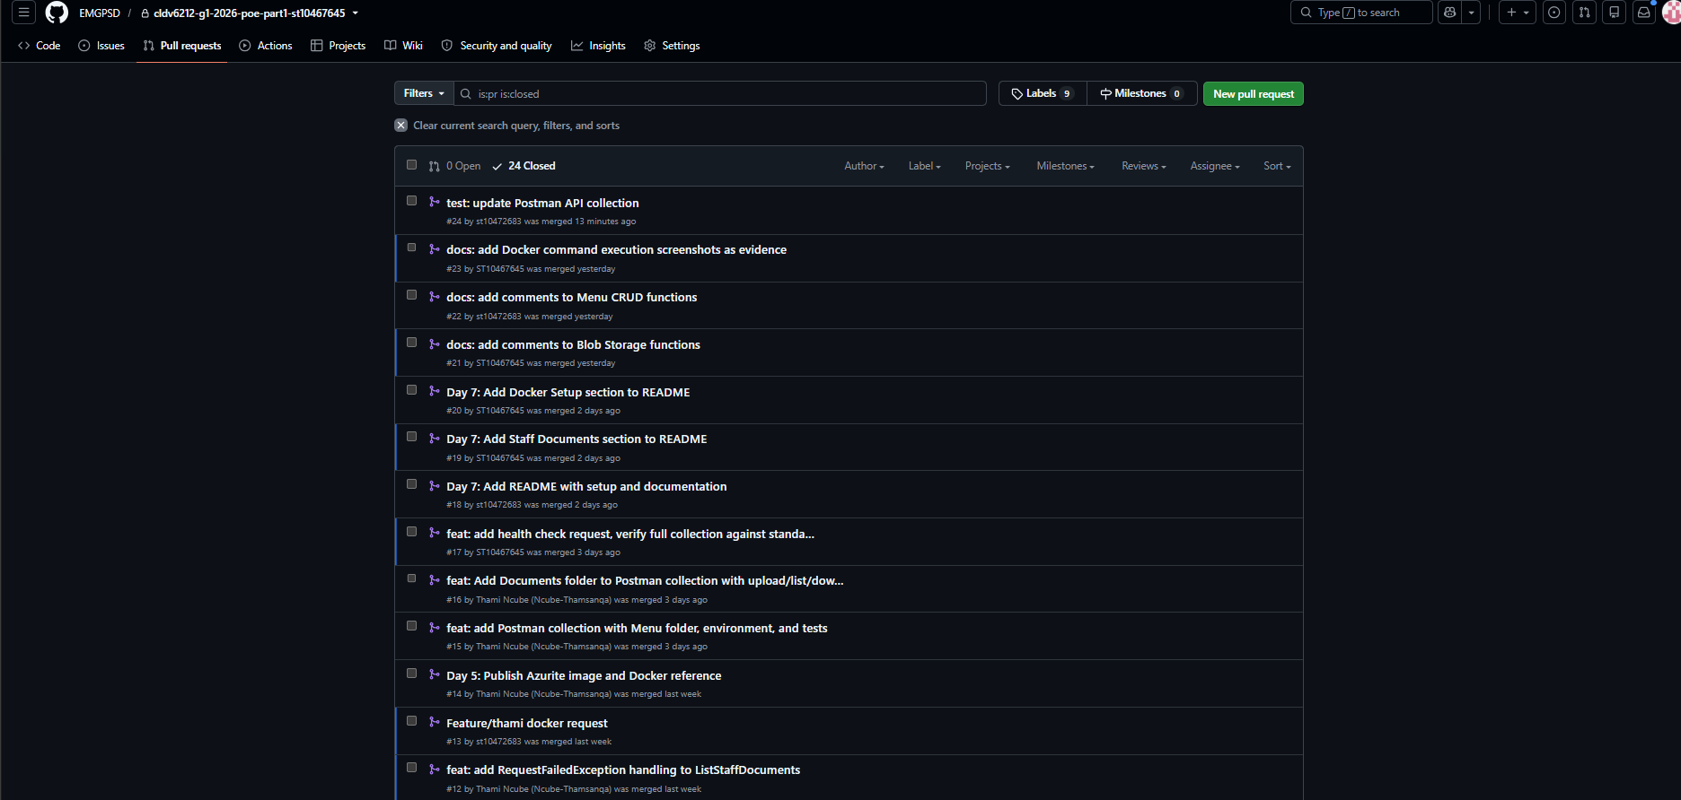
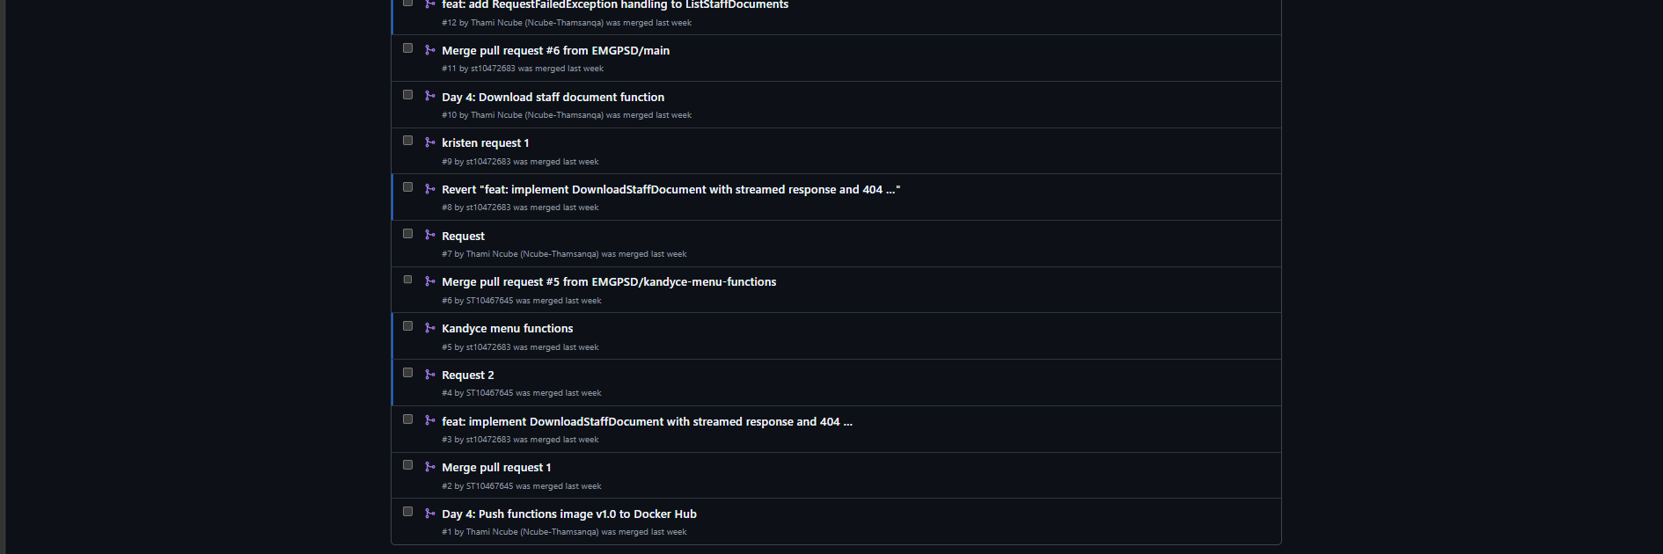

References
Docker, 2026a. Build and push your first image. [Online]
Available at: https://docs.docker.com/get-started/introduction/build-and-push-first-image/
[Accessed 04 September 2026].
Docker, 2026b. Docker Hub quickstart. [Online]
Available at: https://docs.docker.com/docker-hub/quickstart/
[Accessed 04 September 2026].
Docker, 2026c. Push images to a repository. [Online]
Available at: https://docs.docker.com/docker-hub/repos/manage/hub-images/push/
[Accessed 04 September 2026].
Docker, 2026d. Build, tag, and publish an image. [Online]
Available at: https://docs.docker.com/get-started/docker-concepts/building-images/build-tag-and-publish-an-image/
[Accessed 04 September 2026].
Microsoft Learn, 2022. What is Azure Table storage?. [Online]
Available at: https://learn.microsoft.com/en-us/azure/storage/tables/table-storage-overview
[Accessed 04 September 2026].
Microsoft Learn, 2025a. Install and run Azurite emulator. [Online]
Available at: https://learn.microsoft.com/en-us/azure/storage/common/storage-install-azurite
[Accessed 04 September 2026].
Microsoft Learn, 2025b. Azure Functions HTTP trigger. [Online]
Available at: https://learn.microsoft.com/en-us/azure/azure-functions/functions-bindings-http-webhook-trigger?tabs=python-v2%2Cisolated-process%2Cnodejs-v4%2Cfunctionsv2&pivots=programming-language-csharp
[Accessed 04 September 2026].
Microsoft Learn, 2026a. Create your first containerized Azure Functions. [Online]
Available at: https://learn.microsoft.com/en-us/azure/azure-functions/functions-deploy-container
[Accessed 04 September 2026].
Microsoft Learn, 2026b. Work with containers and Azure Functions. [Online]
Available at: https://learn.microsoft.com/en-us/azure/azure-functions/functions-how-to-custom-container
[Accessed 04 September 2026].
Microsoft Learn, 2026c. Azure Tables client library for .NET - version 12.12.0. [Online]
Available at: https://learn.microsoft.com/en-us/dotnet/api/overview/azure/data.tables-readme?view=azure-dotnet
[Accessed 04 September 2026].
Microsoft Learn, 2026d. Download a blob with .NET. [Online]
Available at: https://learn.microsoft.com/en-us/azure/storage/blobs/storage-blob-download
[Accessed 04 September 2026].
Microsoft Learn, 2026e. Introduction to Azure Blob Storage. [Online]
Available at: https://learn.microsoft.com/en-us/azure/storage/blobs/storage-blobs-introduction
[Accessed 04 September 2026].
Microsoft Learn, 2026f. MultipartReader Class. [Online]
Available at: https://learn.microsoft.com/en-us/dotnet/api/microsoft.aspnetcore.webutilities.multipartreader?view=aspnetcore-10.0
[Accessed 04 September 2026].

